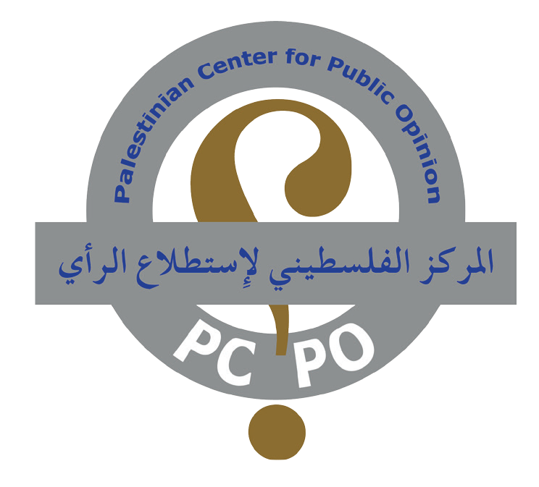

Poll no. 185 March 29, 2014

The most recent poll prepared by Dr. Nabil Kukali on the prisoners’ issue reveals that:

(85.7 %) of the Palestinians support their leadership to resort to the international institutions in case of Israel’s disapproval of the prisoners’ release.

(73.9 %) believe that the release of the fourth batch of prisoners is a pivotal issue.

Beit Sahour – Public Relations Office:

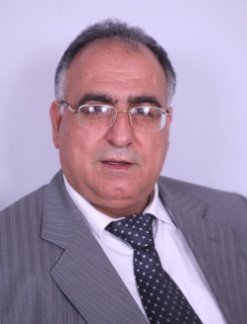
The most recent poll prepared by Dr. Nabil Kukali, conducted by the Palestinian Center for Public Opinion (www.pcpo.org) during the period from March 10 till 14, 2014, covered a random sample of (1010) Palestinian respondents representing the various demographic specimens of adult Palestinians (18 years and above) living in the west Bank, including East Jerusalem, and Gaza Strip. It revealed that (85.7 %) of the Palestinians support their leadership to resort to the international institutions and corporations in case of Israel’s disapproval of the release of the Palestinian prisoners. Dr. Nabil Kukali
Dr. Nabil Kukali, President and founder of the Palestinian Center for Public Opinion, said that the Palestinian public is indignant about the non-commitment of Israel regarding its obligation to implement the deal concluded in July 2013, specifically the release of the Palestinian prisoners versus the suspension of the Palestinians affiliation to influential international institutions and corporations.

In this regard, Dr. Kukali indicated that the release of the Palestinian prisoners from the Israeli jails is a prerequisite for any future progress of the negotiations, particularly as the overwhelming majority of the Palestinians consider the prisoners’ issue as the most crucial issue that must be treated in order to continue with the peace process. He referred to a previous poll published by PCPO on October 30, 2013 showing that (62 %) of the Palestinians believed at that time that the prisoners’ release would persuade them to support the peace process.

Dr. Kukali added that Israel should abide by its obligations under the agreements concluded with the Palestinians as this will be considered as a test or a criterion for its commitment to continue with the peace process and not to resort to crooked ways for the realization of certain objectives. This would, he said, undermine the peace process and subsequently conduce to its failure and the breakdown of the negotiations as the Palestinian leadership is committed before its public to the indispensable constants.

Issues that must be addressed for the sake of the continuation of the peace progress:
Responding to the question:” Which, in your opinion, is the pivotal issue or problem that must be addressed or treated for the continuation of the peace process ?” (Open question), (35.3 %) said “the release of the prisoners”, (33.4 %) “the evacuation of the settlements”, (13.8 %) “further withdrawals from the west Bank”, (14.6 %) said “otherwise” and (2.9 %) said “I don’t know”.

Release of the Prisoners:
(73.9 %) of the Palestinian public consider the release of the fourth batch of the prisoners already agreed upon in the deal forged in July 2013 a pivotal issue for any future progress of the negotiations between the Palestinians and the Israelis, whilst only (22.5 %) opposed that and (3.6 %) declined to give their opinion.

Affiliation to the influential, international institutions and corporations:
(85.7 %) of the respondents support their Palestinian leadership to apply officially and factually for being affiliated to the influential, international institutions and corporations, including the legal corporations that enjoy international competences, in case Israel disapproves of the release of the fourth batch of the Palestinian prisoners, whilst only (9.3 %) of the respondents opposed that and (5.0 %) were reluctant to answer the relevant question.

Methodology of the Survey Study

Mr. Elias Kukali, Head of the Quantitative Researches Department at the PCPO, said that all interviews of this survey were conducted inside the respondents' homes, i.e. face-to-face during different working hours, at least 5 hours a day, including the evening time, in order to ensure proper representation of those sub-groups of the population, which would otherwise be difficult to reach and selecting one individual in each household using Last Birthday Method. The choices were taken from a total of (165) election sites, from which (123) sites are located in West Bank and (42) sites in Gaza Strip according to the distribution of the Central Election Commission. These election sites were randomly chosen by using the method of the simple random sample. These in turn were the beginning of the random sample choice made from those regions in accordance with PCPO's long experienced methodology.

Mr. Elias Kukali has further established that the margin of error was (±3.08%) at a significance and confidence levels of (5.0%) and (95%) respectively. He added that the rate of the female respondents in this survey was (49.3%) against (50.7%) male respondents. The distribution of the random sample between the Palestinian two major regions was (62.5%) in the West Bank, including East Jerusalem, and (37.5%) in Gaza Strip.

About PCPO
The Palestinian Center for Public Opinion (PCPO) is a leading full service research institute in Palestine and in a position to organize, implement, handle and conduct national and regional field surveys, studies and researches of any size within the Middle East and North Africa (MENA). The PCPO is founded in February 1994 in Beit Sahour by Dr. Nabil Kukali, who became the president of this center since that time. After the arrival of the Palestinian Authority (PA), the PCPO was registered as a research center under license number (Am/2). The Palestinian Ministry of information issued the license that permits establishing satellite offices elsewhere in the West Bank and Gaza Strip. Furthermore, PCPO is registered as a licensed business at the Ministry of Treasury under number 989326251. In addition, we are a member of WIN/Gallup International, ANPOP, WAPOR and ESOMAR.

Since its foundation, PCPO is dedicated to the following activities:
1) Conducting public opinion surveys.
2) Omnibus polls and services.
3) Market studies on all kinds of trading activities.
4) Surveys of consumer attitudes, consumption habits, and market shares.
5) Pre- and Post-Advertising and Communication Research
6) Pricing.
7) Focus group sessions and workshops on various topics.
8) Rendering services in the field of investment, including feasibility studies.
9) In-depth interviews & brainstorming workshops.
10) Branding and brand tracking.
11) Customer care research.
12) Social and Public Space research.
13) Household consumer survey.
14) Business – to- business survey.
15) Market Appraisal Studies.
16) Media Research.
17) Usage and Attitude.
18) Translation services from Arabic into English, German & Hebrew and vice-versa.

PCPO is now a name for reliability, credibility, competence and experience not only in Palestine, but all over the world.

Contact Information
Please contact us if you have any questions about Research & Polling and its services.
Contact Persons: Dr. Nabil Kukali & Elias Kukali
Tel: 00970. 2. 277 4846, Fax: 00970- 2- 2774892
Mobile: 00970 599 726 878
P. O. Box 15, Beit Sahour - Palestine
Email: dr.kukali@pcpo.org
Website: www.pcpo.org

