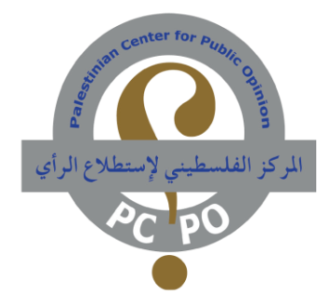
Poll No. 202 November 15, 2016

The latest poll on the Palestinian public opinion, prepared by Dr. Nabil Kukali, revealed the following key results:
- (70.0%) of the Palestinians – to various degrees - don’t trust Benjamin Netanyahu and his commitment to the two-state solution.
- (53.5%) oppose the return to the direct negotiations with the Israelis after their denial of the French Initiative.
- (51.1%) are pessimistic about achieving reconciliation between Fatah and Hamas.
- (33.5%) support the stance of the Palestinian Authority on the French Initiative.
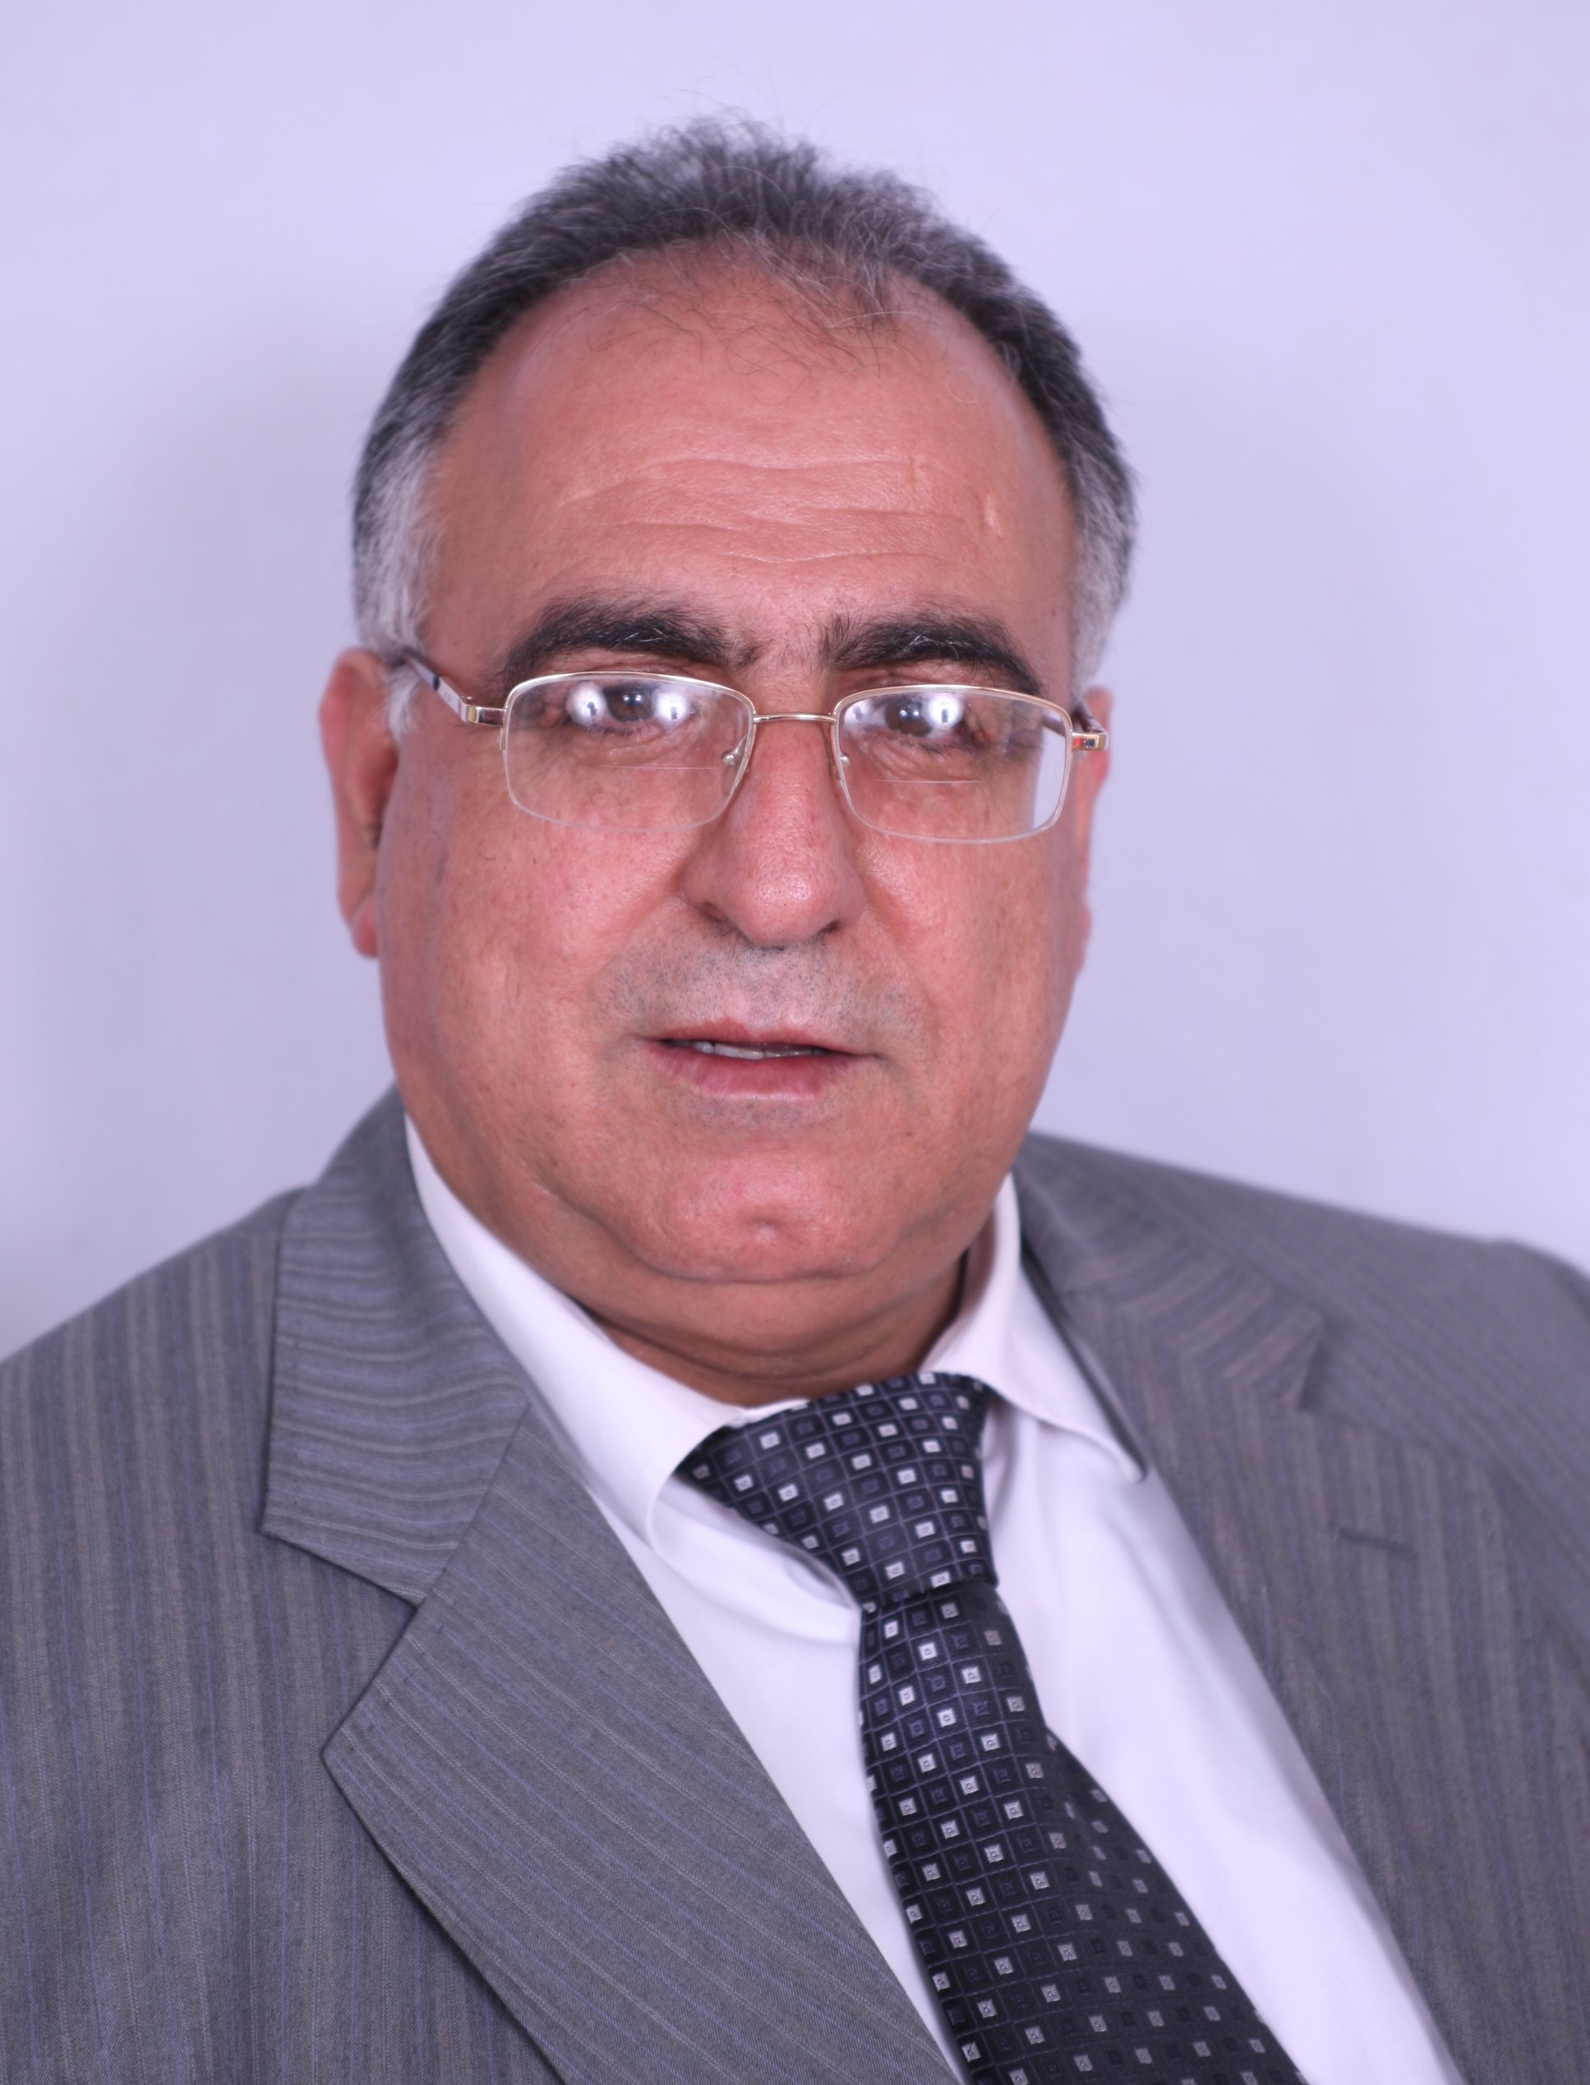
Beit Sahour –Public Relations’ Section – by Adham Kukali:
The latest poll prepared by Dr. Nabil Kukali and conducted by the Palestinian Center for Public Opinion (www.pcpo.org covered a random sample of (1000) Palestinian respondents representing the various demographic specimens of Palestinians (18 years and above) living in the West Bank, including East Jerusalem, and Gaza Strip. It revealed that (53.5%) of the Palestinian public oppose the return to the direct negotiations with the Israelis after their denial of the French initiative, namely the call for an international peace conference between Israel and the Palestinians.
Dr. Kukali
Dr. Nabil Kukali, President and founder of the Palestinian Center for Public Opinion, said in a statement that the denial of the French initiative by the Israeli government has the consequence that the Palestinians don’t trust the government of Benjamin Netanyahu to find a radical and just solution to end the Israeli – Palestinian conflict and build bridges of trust between the two sides. Dr. Kukali added that he believes the Trump administration must focus on a reconciliation process between the Israelis and the Palestinians on the basis of people-to-people activities that would alleviate the profound mutual distrust and suspicion and ingrain love instead of hatred and amicability instead of a animosity and tolerance instead of intolerance and intransigence, enabling thereby both parties to reach the desired peace. Dr. Kukali asserted that the Israeli government, by its denial of the French initiative, has in fact undermined a real opportunity to help both sides return to the negotiation table, as the result thereof is that around (70%) of the Palestinian public mistrust Netanyahu’s government regarding its commitment to a just and perpetual two-state solution to this since seven decades simmering and self-destructive conflict. Dr. Kukali further concluded that the Palestinian public is deep pessimistic about the future and the perspective of reaching a reconciliation between Fatah and Hamas and pointed out that the most significant issue at this juncture is working hard to align and consolidate all possible efforts to a national unity and a genuine partnership that might boost the internal front as to end the schism between the major two political movements of the country.
The most outstanding results of this poll, Dr. Kukali said, are as follows:
Responding to the question “Do you think that the French initiative of convening an international peace conference will succeed or fail after Israel’s denial?” (44.0%) said “it will be a failure”, (18.7%) “it will succeed” and (37.3%) said “I don’t know”.
And regarding the question: “In your view, would the French initiative meet the Palestinian requirements in the peace process?” (35.2%) said “Yes”, (41.0%) said “No” and (23.8%) said “I don’t know”.
With respect to the question: “Do you support or oppose the stance of the Palestinian National Authority that is in favor of the French initiative?”, (33.5%) said they support, (32.5%) oppose and (34%) said “I don’t know”.
Furthermore, (53.5%) of the Palestinian public oppose the return to direct negotiations with the Israelis after their denial of the French Initiative, whilst (32.4%) support that and (14.1%) declined to respond to the relevant question.
With regard to the question: “What is the extent of your confidence that the government of Benyamin Netanyahu is committed to a fair and perpetual two-state solution to the Israeli-Palestinian conflict?”, (1.6%) said “very confident”, (9.8%) “somehow confident”, (25.6%) “somewhat not confident”, (44.5%) “not confident at all”, and (18.5%) said they are not sure.
And responding to the question: “In the light of Israel’s denial of the French Initiative and the prevailing political and economical conditions in the Palestinian territories, are you optimistic or pessimistic about the future?” (59.2%) said they are pessimistic, (25.1%) optimistic and (15.7%) said “I don’t know”.
In conclusion, responding to the question: “Are you optimistic or pessimistic about reaching a reconciliation between Fatah and Hamas”, (51.1%) said they are pessimistic, (29.2%) said optimistic and (19.7%) said: “I don’t know”.
Methodology of the Survey Study
Mr. Elias Kukali, Head of the Quantitative Researches Department at the PCPO, said that all interviews of this survey were conducted inside the respondents' homes, i.e. face-to-face during different working hours, at least 5 hours a day, including the evening time, in order to ensure proper representation of those sub-groups of the population, which would otherwise be difficult to reach and selecting one individual in each household using Last Birthday Method. The choices were taken from a total of (168) election sites, from which (124) sites are located in West Bank and (44) sites in Gaza Strip according to the distribution of the Central Election Commission. These election sites were randomly chosen by using the method of the simple random sample. These in turn were the beginning of the random sample choice made from those regions in accordance with PCPO's long experienced methodology.
Mr. Elias Kukali has further established that the margin of error was (±3.09%) at a significance and confidence levels of (5.0%) and (95%) respectively. He added that the rate of the female respondents in this survey was (49.8%) against (50.2%) male respondents. The distribution of the random sample between the Palestinian two major regions was (61.8%) in the West Bank, including East Jerusalem, and (38.2%) in Gaza Strip.

About PCPO
The Palestinian Center for Public Opinion (PCPO) is a leading full service research institute in Palestine and in a position to organize, implement, handle and conduct national and regional field surveys, studies and researches of any size within the Middle East and North Africa (MENA). The PCPO is founded in February 1994 in Beit Sahour by Dr. Nabil Kukali, who became the president of this center since that time. After the arrival of the Palestinian Authority (PA), the PCPO was registered as a research center under license number (Am/2). The Palestinian Ministry of information issued the license that permits establishing satellite offices elsewhere in the West Bank and Gaza Strip. Furthermore, PCPO is registered as a licensed business at the Ministry of Treasury under number 989326251. The Palestinian Center for Public Opinion (PCPO) is an independent institution and is not affiliated or biased to any political inclination or party. In addition, public opinion polls and surveys are conducted by PCPO with utmost neutrality and professionalism and PCPO is devoted to provide researchers, research centers and universities, policy makers, Palestinian political parties, business men, the media, any parties interested or involved in Palestinian affairs as well as ordinary people with reliable information and data on the level and inclinations of the Palestinian public opinion with regard to topics and politics of general, public interest. In addition, we are a member of WIN/Gallup International, ANPOP, WAPOR and ESOMAR.
Since its foundation, PCPO is dedicated to the following activities:
1) Conducting public opinion surveys.
2) Omnibus polls and services.
3) Market studies on all kinds of trading activities.
4) Surveys of consumer attitudes, consumption habits, and market shares.
5) Pre- and Post-Advertising and Communication Research
6) Pricing.
7) Focus group sessions and workshops on various topics.
8) Rendering services in the field of investment, including feasibility studies.
9) In-depth interviews & brainstorming workshops.
10) Branding and brand tracking.
11) Customer care research.
12) Social and Public Space research.
13) Household consumer survey.
14) Business – to- business survey.
15) Market Appraisal Studies.
16) Media Research.
17) Usage and Attitude.
18) Mystery shopping
19) Translation services from Arabic into English, German & Hebrew and vice-versa.
20) Training services that include civic education issues i.e. political systems, democracy and human rights, pluralism, citizenship, gender equality, women rights, conflict resolution, elections, media, leadership, team work, statistical programs, institution management.
PCPO is now a name for reliability, credibility, competence and experience not only in Palestine, but all over the world.

Contact Information
Please contact us if you have any questions about Research & Polling and its services.
Contact Persons: Dr. Nabil Kukali & Elias Kukali
Tel: 00970. 2. 277 4846, Fax: 00970- 2- 2774892
Mobile: 00970 599 726 878
P. O. Box 15, Beit Sahour - Palestine
Email: dr.kukali@pcpo.org
Website: www.pcpo.org

